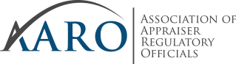

AARO Business Meeting
Westin Washington DC City Center
1400 M Street NW in Washington, DC 20005
Sunday, October 17, 2021 at 11:00 AM

BUSINESS MEETING AGENDA

- Call to Order / Roll Call
- President Remarks
- Adoption of Minutes
- Committee & Advisory Council Reports (Floor)
- ASC Advisory Council
- Appraisal Qualifications Advisory Council
- Past Presidents Advisory Council
- Professional Organizations Advisory Council
- USPAP Advisory Council
- Education Committee
- Budget & Finance Committee
- Communications Committee
- Planning & Policy Committee
- Program Committee
- Nominating Committee
- Vote on Bylaw Revisions
- Vote on New Officers/Directors/Alternate Directors
- Comments from Membership
- Awards Presentation
- Installation of Officers
- Last Minute Comments
- Adjourn

